

**CS6313 Assignment 2**

**Name:** Charles beyer

**Student No.:** 117222082

**Other team member:** Mike Glover

Travelee

**Description of how your service will support mobile applications:**

The service will be an API that will be able to process client requests. Through their queries, the mobile applications will be able to interact with the data stored inside our service, but also call functions that will return processed data. This data will be returned inside a JSON object, so that the applications can easily parse it.

**Service supporting architecture:**

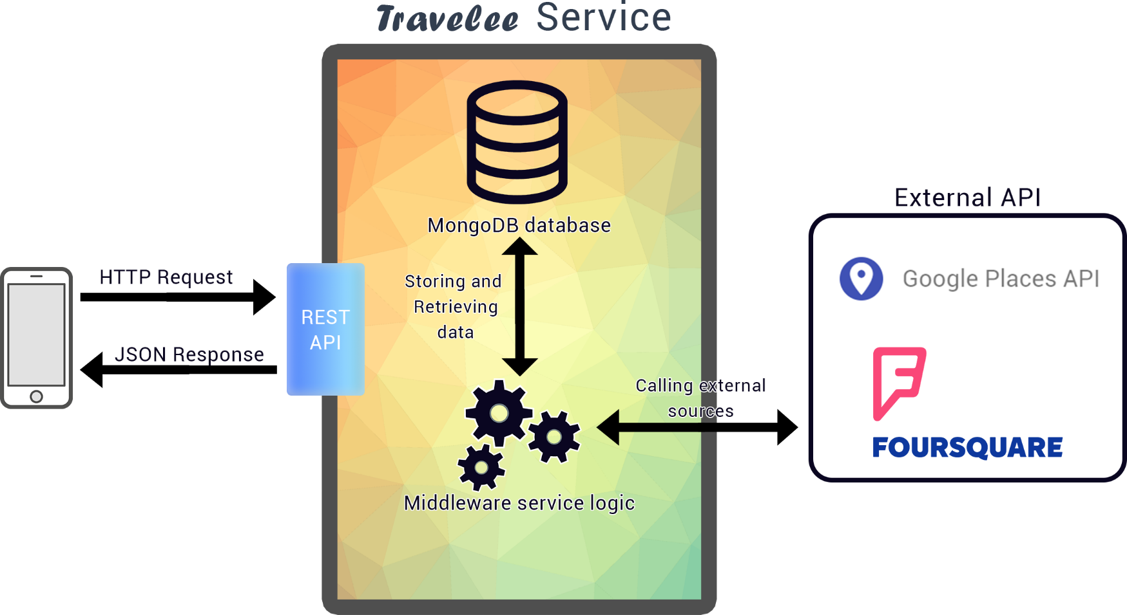The Travelee middleware service will be built with Node.js, following a MVC pattern for our REST API. The service will support GET, PUT and DELETE client requests to process and return data. Multiple URL paths will be made depending of the data needed by the client application and the kind of process data the service needs to generate.  
The data will be stored inside a MongoDB no-sql database, in order to have a scalable and easy to manipulate database. The service will also make calls to other API such as Google Places and Foursquare, to get better and more accurate results. Once the data from external API’s is processed, it will return a JSON response with the list of recommended trips back to the user.

**Service protocols;**

Because the service makes use of RESTful interfaces, it will use HTTP as its underlying web service protocol. That way, we will be able to use data from different sources such as Foursquare and Google Places.

**My part in the design of the service:**

I designed a first draft of the Node.js REST API, with a list of functions to be used depending of the type of request sent. The functions need to be improved, so that it can handle data from foreign sources, process it, and send it back to the client.